Node JS 22.18.0 installed

Project created using vite:

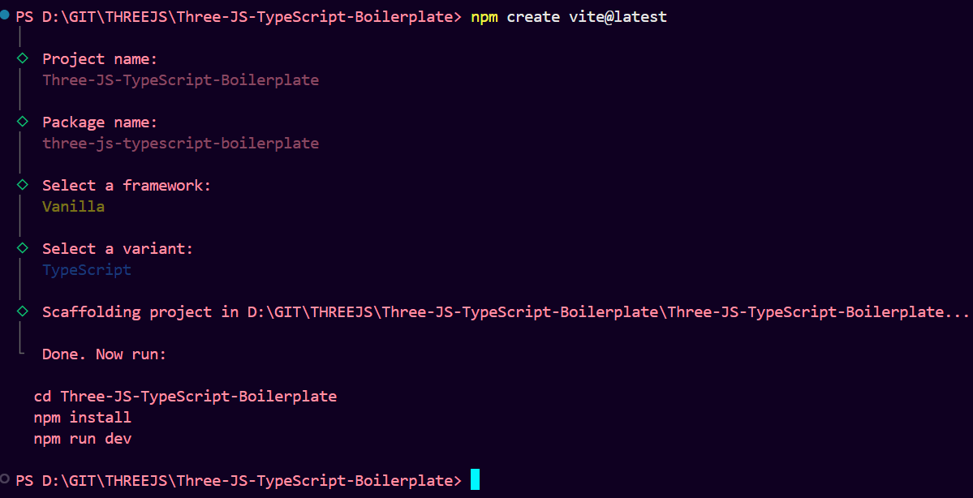

Once project created navigate to project folder and type below command in terminal:

CMD: npm install

We can check if installation correct or not by running our project using below command:

CMD: npm run dev

From public folder delete vite.svg

From src folder delete counter.ts and typescript.svg

Npm install three –save-dev

npm install @types/three --save-dev

in Vite we have to mention *.js extension while importing package

Difference between TypeScript and JavaScript is TypeScript force us for syntactically error correction whereas JavaScript don’t

Typescript issue in tsconfig.json:

Error:  
Unknown compiler option 'erasableSyntaxOnly'.ts Do not allow runtime constructs that are not part of ECMAScript.

In PowerShell:  
npm i -D typescript@latest  
npx tsc -v

Zero Dimension= no direction, only dot

One Dimension = A line with no width and height

Two Dimension = Is shape with width and height but no depth like paper or 2D games like super Mario

Three Dimension = Is Space, where shape having width, height and depth , giving them volume. Humans are in 3d shapes

Fourth Dimension = is time

Ricardo Cabello is founder of three JS.

He started the project around 2010.

Three.js is an open-source JavaScript 3D library that makes it much easier to create and display 3D graphics in the browser using WebGL.

Scene in three JS is section where we build the 3d application.

a scene is like the "container" or "stage" where you put everything that makes up your 3D world.

**The scene** = the stage itself.

**Objects (meshes, lights, cameras)** = actors, props, and lights on the stage.

**The renderer** = the audience’s eyes (it looks at the stage and shows the result on screen).

In **Three.js**, a **camera** is your point of view — it defines **where you’re looking from** and **what part of the scene you can see**.

If the **scene** is a theatre stage, then the **camera** is the audience’s eyes (or even a virtual video camera) that looks at the stage. Without a camera, you can have a scene full of objects, but nothing will show up when rendering.

npm install dat.gui@latest --save-dev

npm install @types/dat.gui@latest --save-dev

[Dat GUI - Three.js Tutorials](https://sbcode.net/threejs/dat-gui-module/)